**AIM:**

To implement an **AVL Tree** in C that supports insertion and maintains balance.

**📌 What is an AVL Tree?**

An **AVL Tree** is a self-balancing binary search tree (BST) where the **balance factor** (difference between heights of left and right subtrees) of every node is **-1, 0, or +1**.

When inserting nodes, the tree re-balances itself using **rotations**:

* **LL Rotation** (Right rotation)
* **RR Rotation** (Left rotation)
* **LR Rotation** (Left-Right)
* **RL Rotation** (Right-Left)

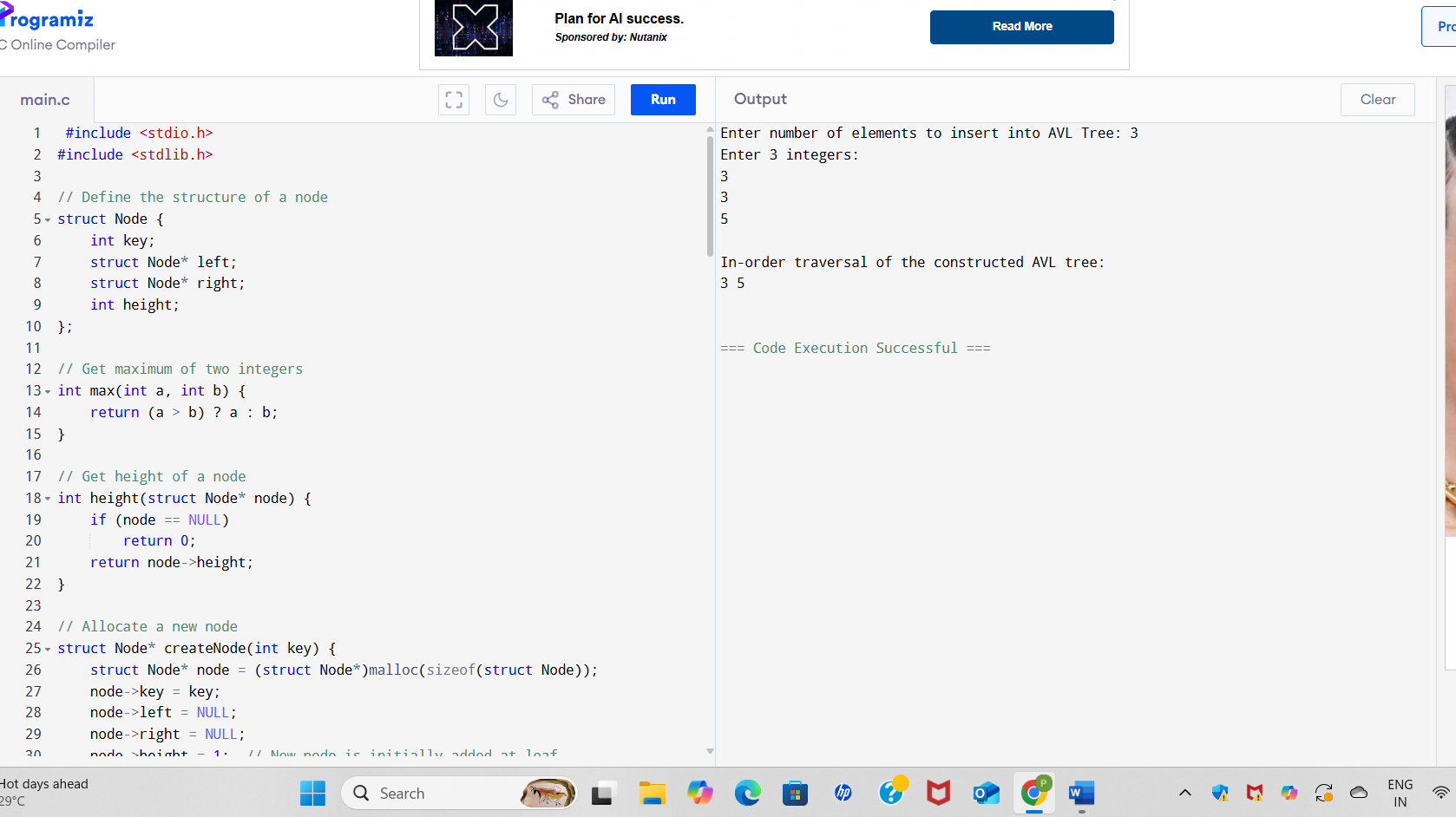

**SAMPLE OUTPUT:**

Enter number of elements to insert into AVL Tree: 6

Enter 6 integers:

30 20 40 10 25 50

In-order traversal of the constructed AVL tree:

10 20 25 30 40 50